CSE331: Automata and Computability

Summer’25 **|** Assignment 1

Deadline: 24th July, 2025

Question 1 [10 marks]

**Draw state diagram for a DFA of the following regular languages:**

1. L = {w ∈ string that has “b” in the second last digit}, Σ = {a, b}
2. L2 = {w ∈ a string starts with ‘ba’ and contains 'bba'}, Σ = {a, b}
3. L3 = {w ∈ a string where 0 is followed by at least one 1}, Σ = {0, 1}
4. L4 = {w ∈ {0, 1} | w ends with 0 and does not contain the substring 11}
5. L5 = {w ∈{a, b}: length of w is multiple of 3 ∩ contains at least two a’s}

Question 2 [10 marks]

Let **Σ = {a, b}**. Consider the following languages over Σ.

*L1* = {w : w a string that starts and ends with different symbol}

*L2* = {w : a string that has *subsequence* of ‘aa’}

*L3* = {w : a string that contains 'aba' and ends with 'b'} *L4* = {w ∈ {01, 1}*}

(a) Give the state diagram for a **DFA** that recognizes $\underline{L2}$.

(b) How many states will be there for $L1$ *∩ L2, if use cross product rule?*

(c) Draw a **DFA** state diagram for $L1 ∩ L2$*.*

(d) Find all the unique strings of **length** **four** for *L4*\*.

(e) Give the state diagram for a **DFA** that recognizes *L3*.

Question 3 [5 marks]

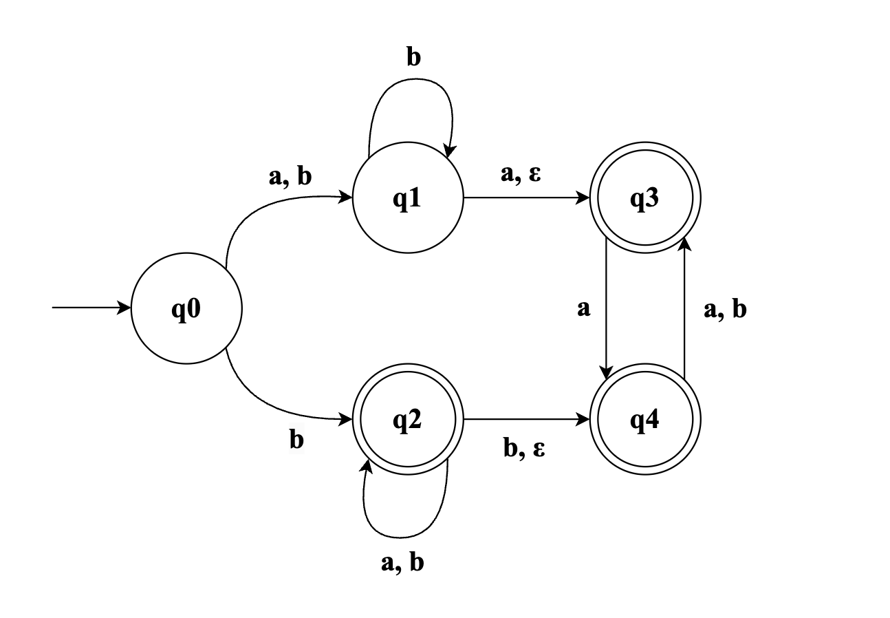

(a) When converting the given NFA to an equivalent DFA using the subset construction method, what is the maximum number of states that the resulting DFA can have? (1 Point)

(b) Identify the subsets of states from the given NFA that will correspond to the rejecting states in its equivalent DFA. (1 Point)

(c) Determine the ε-closure of state q2 in the given NFA. (1 Point)

(d) What is δ({q0, q4}, a) in the given NFA? List all the states. [Recall: δ({q}, 0) refers to the set of states the NFA transitions to when it is in state q and receives input a.] (1 Points)

(e) What would be the start state of the converted DFA? Write the subset of the start state.

Question 4 [5 marks]

**Draw state diagram for a NFA of the following regular languages:**

1. L1 = {w ∈ a string that contains ‘aba’ ∩ ends with ‘aab’}, Σ = {a, b}
2. L3 = {w ∈ a string where third last symbol is ‘b’}, Σ = {a, b}

Question 5 [20 marks]

**Let Σ = {0, 1}. Give regular expressions generating each of the following languages over Σ.**

(a) {w : w starts with a 1 and ends in a 0}

(b) {w : the length of w is even}

(c) {w : every 1 in w is followed by an even number of 0s}

(d) {w : w does not contain 10}

(e) {w : 10 appears in w exactly once}

(Hint: If w = x10y, what can you say about x and y?)

(f) {w : w containing strings where 0’s and 1’s are alternate}

(g) {w : w containing strings where every third position in w is 1}

(h) {w : w containing strings where every 1 in w is followed by at least two 0}

(i) {w : w containing strings where every third position in w is 1 *∩* every 1 in w is followed by at least two 0}

(j) {w : w containing strings that end in three consecutive 1’s}

Question 6 [5 marks]

**Convert Regular Expression to NFAs:**

1. (a++ b)*b + a (ba)*
2. (a+ b + c)* b + c+

Question 7 [5 marks]

Convert the following DFA into an equivalent regular expression using the state elimination method. **Must follow this sequence to eliminate: C, D, E, F, A, B**. Show all steps.

